EXPERIMENT NO. 51
TRAVELING SALESPERSON PROBLEM – FIVE CITIES
QUESTION: Assume a TSP for four cities and add a fifth city E. Find the shortest route for the given symmetric distances: AB=10, AC=15, AD=20, AE=25, BC=35, BD=25, BE=30, CD=30, CE=20, DE=15.
AIM: To find the shortest Hamiltonian cycle through five cities using dynamic programming.
PSEUDOCODE: 1. Store the distance matrix.
2. Fix city A as the starting city.
3. Generate DP states (visited set, current city).
4. Compute the minimum cost to reach every state.
5. Add the return cost to A.
6. Print the minimum tour cost.
INPUT (C PROGRAM):
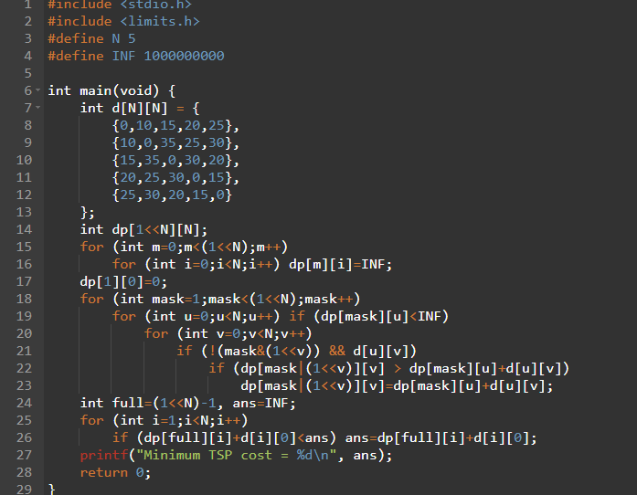
OUTPUT:
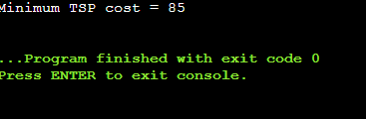
TIME COMPLEXITY: O(n^2 2^n)
SPACE COMPLEXITY: O(n 2^n)
RESULT: The program successfully implements the required algorithm for the given problem.
EXPERIMENT NO. 52
LONGEST PALINDROMIC SUBSTRING
QUESTION: Given a string s, return the longest palindromic substring. Examples: babad → bab (or aba), cbbd → bb.
AIM: To find the longest palindromic substring using dynamic programming.
PSEUDOCODE: 1. Create dp[i][j] to indicate whether s[i..j] is a palindrome.
2. Process substrings by increasing length.
3. Mark length 1 and 2 cases.
4. For longer strings, use dp[i+1][j-1].
5. Track the longest interval.
INPUT (C PROGRAM):
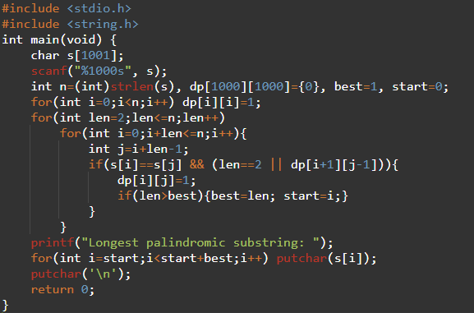
OUTPUT:
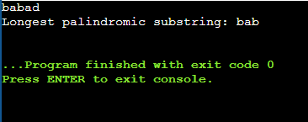
TIME COMPLEXITY: O(n^2)
SPACE COMPLEXITY: O(n^2)
RESULT: The program successfully implements the required algorithm for the given problem.

EXPERIMENT NO. 53
LONGEST SUBSTRING WITHOUT REPEATING CHARACTERS
QUESTION: Given a string s, find the length of the longest substring without repeating characters. Examples: abcabcbb → 3, bbbbb → 1, pwwkew → 3.
AIM: To determine the longest substring with all distinct characters.
PSEUDOCODE: 1. Keep the last index of each ASCII character.
2. Maintain the left boundary of the current window.
3. Move the right boundary through the string.
4. If a character repeats inside the window, move left.
5. Track the maximum window length.
INPUT (C PROGRAM):
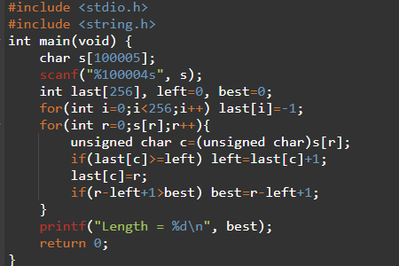
OUTPUT:
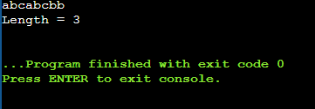
TIME COMPLEXITY: O(n)
SPACE COMPLEXITY: O(1)
RESULT: The program successfully implements the required algorithm for the given problem.

EXPERIMENT NO. 54
WORD BREAK
QUESTION: Given a string s and a dictionary, return true if s can be segmented into dictionary words. Examples: leetcode with {leet,code} → true; catsandog → false.
AIM: To determine whether a string can be segmented using dynamic programming.
PSEUDOCODE: 1. Let dp[i] mean the prefix of length i can be segmented.
2. Set dp[0]=true.
3. For each position i, try every dictionary word.
4. If the word matches the substring ending at i and dp[start] is true, set dp[i]=true.
5. Print the final state.
INPUT (C PROGRAM):
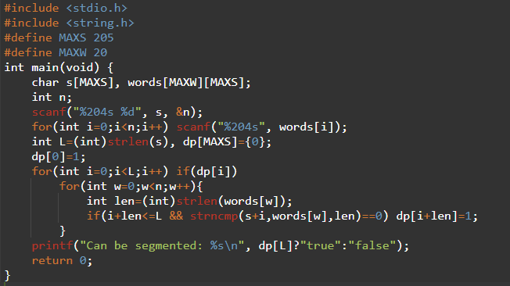
OUTPUT:
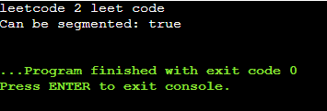
TIME COMPLEXITY: O(n*k*L)
SPACE COMPLEXITY: O(L)
RESULT: The program successfully implements the required algorithm for the given problem.

EXPERIMENT NO. 55
WORD BREAK USING GIVEN DICTIONARY
QUESTION: Using the dictionary {i, like, sam, sung, samsung, mobile, ice, cream, icecream, man, go, mango}, determine whether ilike and ilikesamsung can be segmented.
AIM: To apply the Word Break dynamic-programming method to the supplied dictionary.
PSEUDOCODE: 1. Store the dictionary.
2. Build a boolean DP array for prefixes.
3. Mark a prefix reachable when a dictionary word completes it.
4. Print whether the complete string is reachable.
INPUT (C PROGRAM):
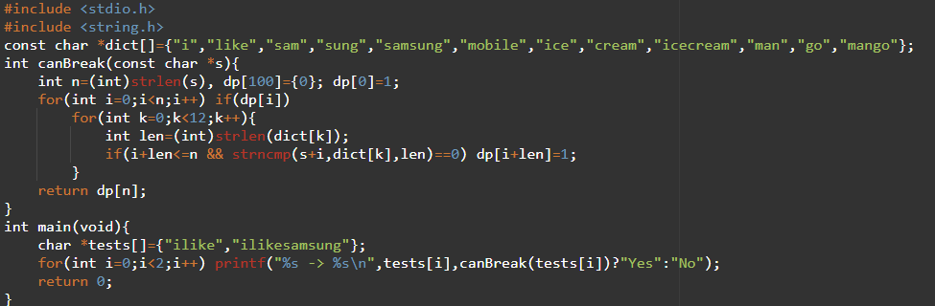OUTPUT:
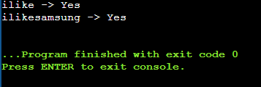
TIME COMPLEXITY: O(L*D*W)
SPACE COMPLEXITY: O(L)
RESULT: The program successfully implements the required algorithm for the given problem.

EXPERIMENT NO. 56
TEXT JUSTIFICATION
QUESTION: Given words and maxWidth, format text so each line has exactly maxWidth characters, using greedy packing and full justification except for the last line.
AIM: To format text into fully justified lines using the specified greedy rule.
PSEUDOCODE: 1. Greedily select as many words as fit.
2. For a normal line, calculate total spaces and distribute them evenly.
3. Give extra spaces to left gaps.
4. Left-justify the final line and single-word lines.
5. Print every line.
INPUT (C PROGRAM):
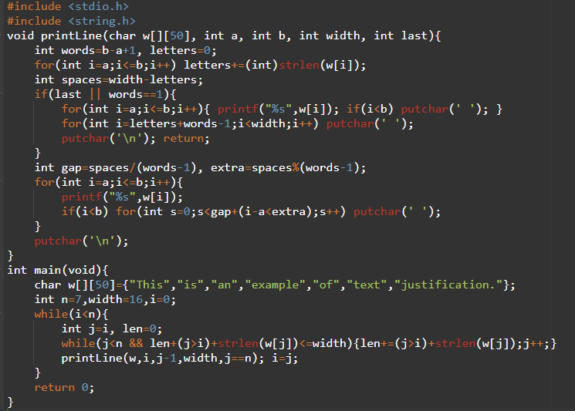
OUTPUT:
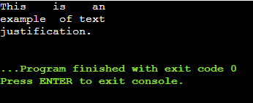
TIME COMPLEXITY: O(n)
SPACE COMPLEXITY: O(1) auxiliary
RESULT: The program successfully implements the required algorithm for the given problem.

EXPERIMENT NO. 57
PREFIX AND SUFFIX WORD FILTER
QUESTION: Design a dictionary that returns the largest index of a word matching a given prefix and suffix.
AIM: To implement prefix-suffix searching for the supplied WordFilter problem.
PSEUDOCODE: 1. Store all words.
2. For each query, scan from the largest index down.
3. Check whether the word begins with the prefix.
4. Check whether it ends with the suffix.
5. Return the first matching index or -1.
INPUT (C PROGRAM):
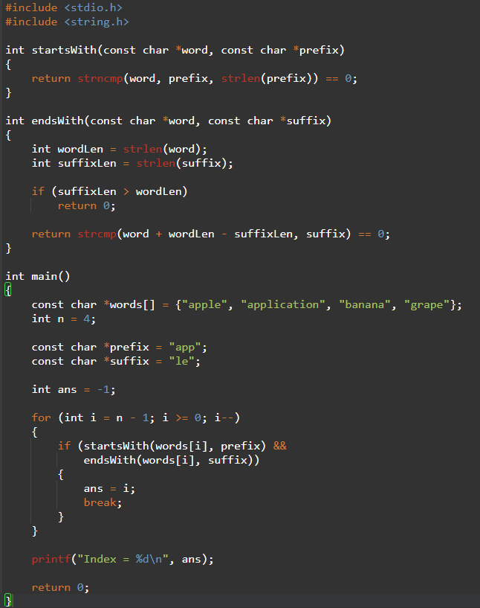
OUTPUT:
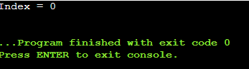
TIME COMPLEXITY: O(n*L) per query
SPACE COMPLEXITY: O(1) auxiliary
RESULT: The program successfully implements the required algorithm for the given problem.

EXPERIMENT NO. 58
FLOYD-WARSHALL ALL-PAIRS SHORTEST PATHS
QUESTION: Implement Floyd's Algorithm to find shortest paths between all pairs of cities and display the distance matrix before and after the algorithm.
AIM: To compute all-pairs shortest paths using Floyd-Warshall dynamic programming.
PSEUDOCODE: 1. Initialize the distance matrix from the graph.
2. For each intermediate vertex k, consider every pair i,j.
3. Replace d[i][j] by min(d[i][j], d[i][k]+d[k][j]).
4. Print the final matrix.
INPUT (C PROGRAM):
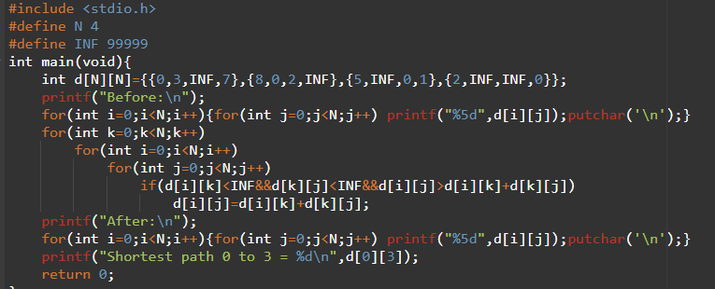OUTPUT:
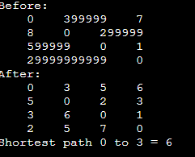
TIME COMPLEXITY: O(n^3)
SPACE COMPLEXITY: O(n^2)
RESULT: The program successfully implements the required algorithm for the given problem.

EXPERIMENT NO. 59
NETWORK SHORTEST PATH WITH LINK FAILURE
QUESTION: Implement Floyd's Algorithm for the six-router network and simulate failure of the link B-D. Display the shortest path from A to F before and after failure.
AIM: To analyze the effect of a network-link failure using Floyd-Warshall.
PSEUDOCODE: 1. Build the initial router matrix.
2. Run Floyd-Warshall and record A-to-F.
3. Remove the B-D link by setting its distance to INF.
4. Run Floyd-Warshall again.
5. Print both distances.
INPUT (C PROGRAM):
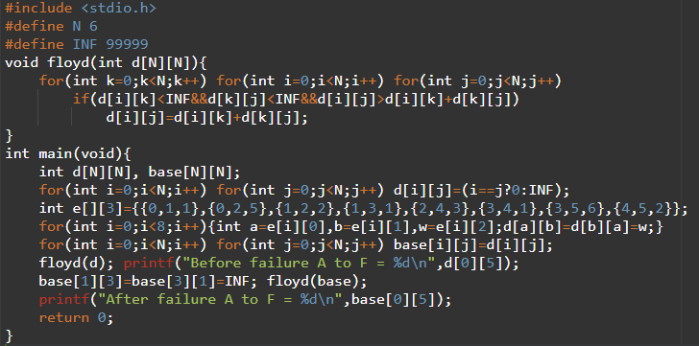
OUTPUT:
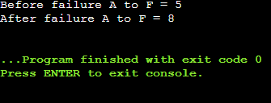
TIME COMPLEXITY: O(n^3)
SPACE COMPLEXITY: O(n^2)
RESULT: The program successfully implements the required algorithm for the given problem.

EXPERIMENT NO. 60
CITY WITH SMALLEST NUMBER OF REACHABLE CITIES
QUESTION: Given a weighted graph and a distance threshold, return the city with the smallest number of reachable cities; break ties by the greatest city number.
AIM: To solve the threshold-reachability problem using Floyd-Warshall.
PSEUDOCODE: 1. Initialize all-pairs distances.
2. Apply Floyd-Warshall.
3. Count distances <= threshold for each city, excluding itself.
4. Choose the smallest count; on ties choose the largest index.
INPUT (C PROGRAM):
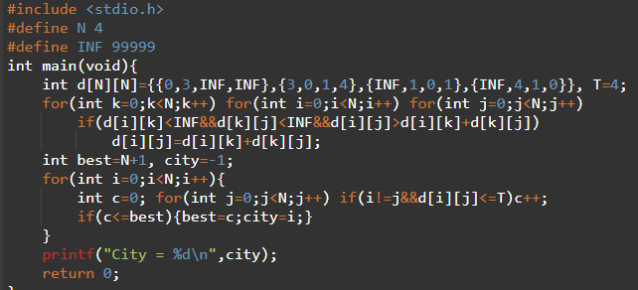
OUTPUT:
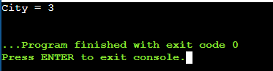
TIME COMPLEXITY: O(n^3)
SPACE COMPLEXITY: O(n^2)
RESULT: The program successfully implements the required algorithm for the given problem.

EXPERIMENT NO. 61
FLOYD-WARSHALL DIRECTED GRAPH
QUESTION: For the supplied directed city graph, compute all-pairs shortest paths and find the shortest path from City 1 to City 3.
AIM: To find shortest paths in a directed graph using Floyd-Warshall.
PSEUDOCODE: 1. Store directed edge weights.
2. Set absent edges to INF.
3. Apply Floyd-Warshall.
4. Read the required source-destination distance.
INPUT (C PROGRAM):
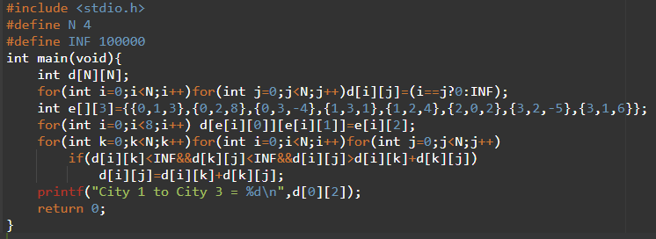OUTPUT:
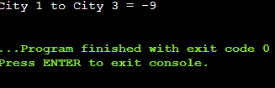
TIME COMPLEXITY: O(n^3)
SPACE COMPLEXITY: O(n^2)
RESULT: The program successfully implements the required algorithm for the given problem.

EXPERIMENT NO. 62
OPTIMAL BINARY SEARCH TREE
QUESTION: Construct an Optimal Binary Search Tree for keys A,B,C,D with frequencies 0.1, 0.2, 0.4, 0.3 and display its cost.
AIM: To construct an OBST with minimum expected search cost.
PSEUDOCODE: 1. Store frequencies.
2. Initialize single-key costs.
3. For every interval length, try every key as root.
4. Cost = left cost + right cost + interval frequency sum.
5. Select the minimum root and cost.
INPUT (C PROGRAM):
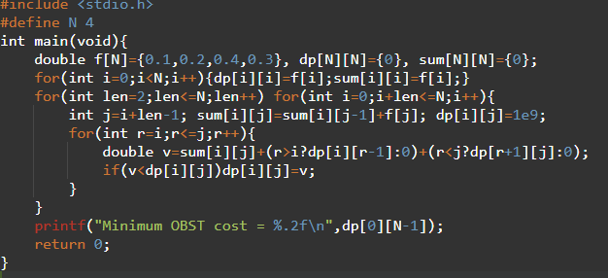
OUTPUT:
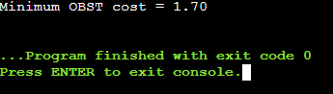
TIME COMPLEXITY: O(n^3)
SPACE COMPLEXITY: O(n^2)
RESULT: The program successfully implements the required algorithm for the given problem.

EXPERIMENT NO. 63
OPTIMAL BINARY SEARCH TREE WITH INTEGER FREQUENCIES
QUESTION: Construct an OBST for keys 10,12,16,21 with frequencies 4,2,6,3 and display its minimum cost.
AIM: To construct an OBST from integer access frequencies.
PSEUDOCODE: 1. Initialize one-key intervals.
2. Compute interval frequency sums.
3. Try every possible root.
4. Select the minimum total weighted search cost.
INPUT (C PROGRAM):
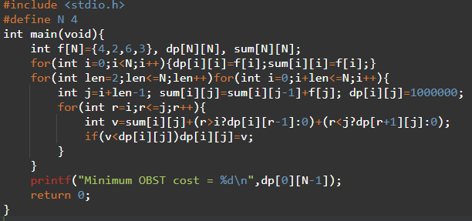
OUTPUT:
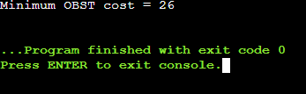
TIME COMPLEXITY: O(n^3)
SPACE COMPLEXITY: O(n^2)
RESULT: The program successfully implements the required algorithm for the given problem.

EXPERIMENT NO. 64
MOUSE AND CAT GAME
QUESTION: Given an undirected graph, determine whether the Mouse wins (1), Cat wins (2), or the game is a draw (0) under optimal play.
AIM: To determine the game result by memoized state-space search.
PSEUDOCODE: 1. Represent a state as mouse position, cat position and turn.
2. Detect terminal Mouse/Cat states.
3. Mark repeated states as draws during recursion.
4. Try all legal moves.
5. If a player can force its winning state, return that result; otherwise return draw.
INPUT (C PROGRAM):
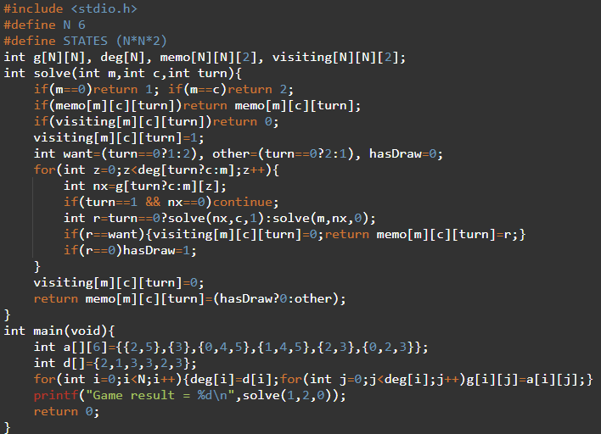
OUTPUT:
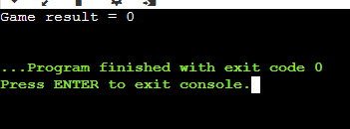
TIME COMPLEXITY: O(n^2)
SPACE COMPLEXITY: O(n^2)
RESULT: The program successfully implements the required algorithm for the given problem.
EXPERIMENT NO. 65
MAXIMUM PROBABILITY PATH
QUESTION: Given an undirected weighted graph with success probabilities, find the path with maximum probability from start to end.
AIM: To compute the maximum-probability path using a Dijkstra-style dynamic method.
PSEUDOCODE: 1. Store adjacency information.
2. Set probability[start]=1.
3. Repeatedly choose the unvisited node with maximum probability.
4. Relax neighbors using prob[u]*edgeProb.
5. Return probability[end].
INPUT (C PROGRAM):
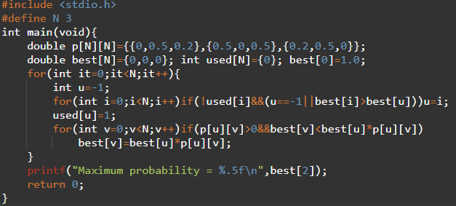
OUTPUT:
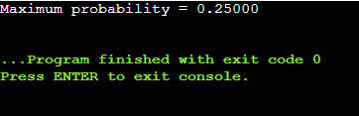
TIME COMPLEXITY: O(n^2)
SPACE COMPLEXITY: O(n^2)
RESULT: The program successfully implements the required algorithm for the given problem.

EXPERIMENT NO. 66
UNIQUE PATHS IN A GRID
QUESTION: A robot moves only down or right in an m×n grid. Return the number of unique paths. Examples: 3×7 → 28 and 3×2 → 3.
AIM: To count unique grid paths using dynamic programming.
PSEUDOCODE: 1. Initialize the first row and first column to 1.
2. For each remaining cell, paths = top + left.
3. Return the bottom-right value.
INPUT (C PROGRAM):
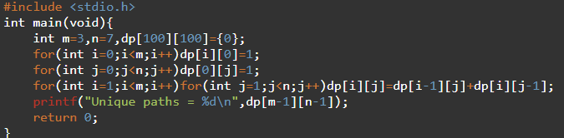
OUTPUT:
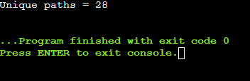
TIME COMPLEXITY: O(mn)
SPACE COMPLEXITY: O(mn)
RESULT: The program successfully implements the required algorithm for the given problem.

EXPERIMENT NO. 67
NUMBER OF GOOD PAIRS
QUESTION: Given an integer array, count pairs (i,j) such that i<j and nums[i]==nums[j].
AIM: To count equal-value pairs efficiently.
PSEUDOCODE: 1. Keep a frequency table.
2. For each value x, add its current frequency to the answer.
3. Increment its frequency.
4. Print the total.
INPUT (C PROGRAM):
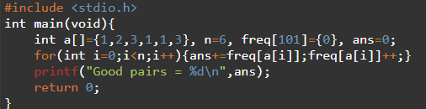
OUTPUT:
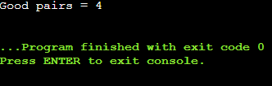
TIME COMPLEXITY: O(n)
SPACE COMPLEXITY: O(V)
RESULT: The program successfully implements the required algorithm for the given problem.

EXPERIMENT NO. 68
NETWORK DELAY TIME
QUESTION: Given directed travel times, find the minimum time for all n nodes to receive a signal from node k; return -1 if impossible.
AIM: To solve the network-delay shortest-path problem.
PSEUDOCODE: 1. Initialize distances from source.
2. Repeatedly choose the unvisited node with minimum distance.
3. Relax all outgoing edges.
4. Find the maximum finite distance.
5. If any node is unreachable, print -1.
INPUT (C PROGRAM):
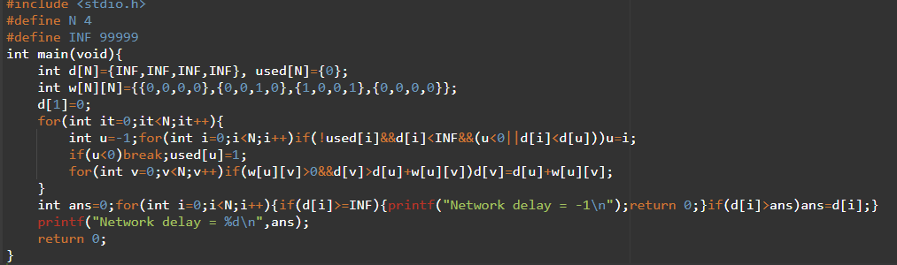OUTPUT:
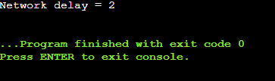
TIME COMPLEXITY: O(n^2)
SPACE COMPLEXITY: O(n^2)
RESULT: The program successfully implements the required algorithm for the given problem.

EXPERIMENT NO. 69
MAXIMUM COINS FROM PILES
QUESTION: Given 3n piles, Alice takes the largest, you take the next largest and Bob takes the last. Maximize your coins.
AIM: To maximize the coins obtained by applying the greedy ordering strategy.
PSEUDOCODE: 1. Sort piles in ascending order.
2. Start from the largest pile.
3. Skip Alice's largest choice.
4. Take the next pile.
5. Skip Bob's smallest remaining pile and repeat.
INPUT (C PROGRAM):
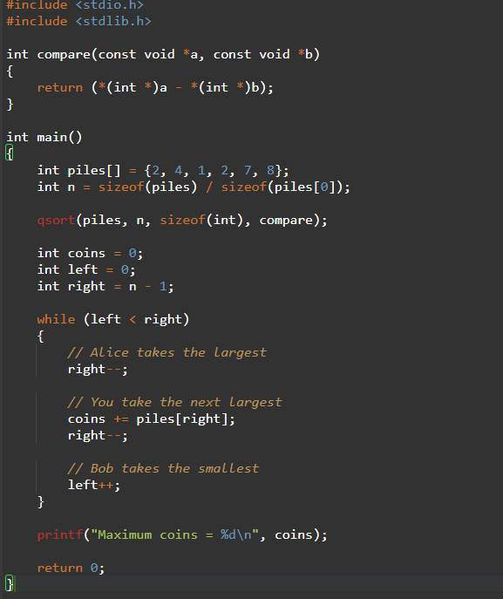
OUTPUT:
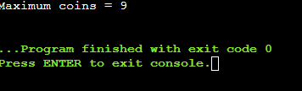
TIME COMPLEXITY: O(n^2) with simple sort
SPACE COMPLEXITY: O(1)
RESULT: The program successfully implements the required algorithm for the given problem.

EXPERIMENT NO. 70
MINIMUM PATCHES
QUESTION: Given sorted positive coins and target, find the minimum number of values to add so every integer in [1,target] is obtainable.
AIM: To cover the range [1,target] with the minimum number of added values.
PSEUDOCODE: 1. Maintain reach, the largest continuously obtainable value.
2. If the next coin <= reach+1, extend reach.
3. Otherwise add reach+1 as a patch.
4. Repeat until reach >= target.
INPUT (C PROGRAM):
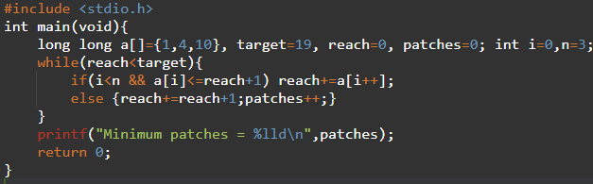
OUTPUT:
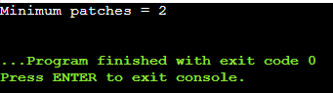
TIME COMPLEXITY: O(n)
SPACE COMPLEXITY: O(1)
RESULT: The program successfully implements the required algorithm for the given problem.

EXPERIMENT NO. 71
MINIMUM MAXIMUM WORKER TIME
QUESTION: Given jobs and k workers, assign every job to exactly one worker so the maximum worker time is minimized.
AIM: To find a balanced assignment of jobs using backtracking with pruning.
PSEUDOCODE: 1. Sort jobs from largest to smallest.
2. Assign each job to a worker.
3. Track the current maximum load.
4. Prune assignments that cannot improve the best result.
5. Return the minimum possible maximum load.
INPUT (C PROGRAM):
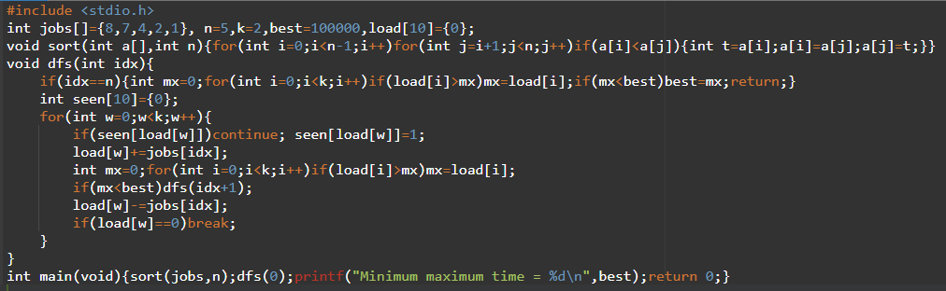OUTPUT:
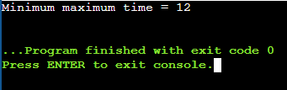
TIME COMPLEXITY: O(k^n) worst case
SPACE COMPLEXITY: O(n+k)
RESULT: The program successfully implements the required algorithm for the given problem.

EXPERIMENT NO. 72
JOB SCHEDULING WITH PROFIT
QUESTION: Given start times, end times and profits, select non-overlapping jobs to maximize total profit.
AIM: To compute the maximum profit from compatible jobs.
PSEUDOCODE: 1. Sort jobs by end time.
2. For each job, find the latest compatible previous job.
3. Use DP: max(skip current, profit + compatible DP).
4. Return the final maximum profit.
INPUT (C PROGRAM):
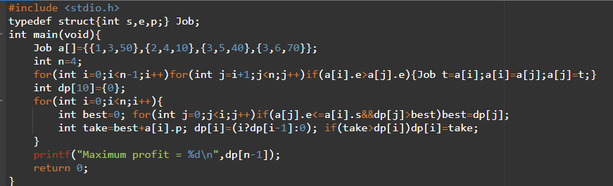OUTPUT:
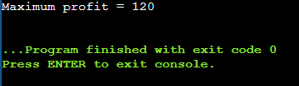
TIME COMPLEXITY: O(n^2)
SPACE COMPLEXITY: O(n)
RESULT: The program successfully implements the required algorithm for the given problem.

EXPERIMENT NO. 73
DIJKSTRA USING ADJACENCY MATRIX
QUESTION: Implement Dijkstra's algorithm using an adjacency matrix to find shortest paths from a source vertex to all other vertices.
AIM: To compute single-source shortest paths in a graph with non-negative weights.
PSEUDOCODE: 1. Set source distance to 0 and all others to INF.
2. Select the unused vertex with smallest distance.
3. Relax all adjacent vertices.
4. Repeat for all vertices.
5. Print the distance array.
INPUT (C PROGRAM):
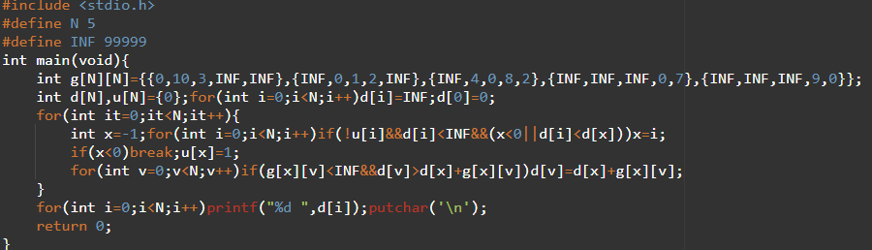OUTPUT:
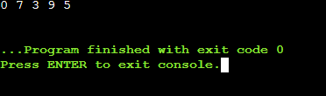
TIME COMPLEXITY: O(n^2)
SPACE COMPLEXITY: O(n)
RESULT: The program successfully implements the required algorithm for the given problem.

EXPERIMENT NO. 74
DIJKSTRA USING EDGE LIST
QUESTION: Implement Dijkstra's algorithm on an edge list to find the shortest path from source 0 to target 4.
AIM: To find a shortest path using an edge-list representation.
PSEUDOCODE: 1. Initialize distances.
2. Repeatedly select the closest unvisited vertex.
3. Scan all edges and relax edges leaving that vertex.
4. Stop when the target is finalized.
INPUT (C PROGRAM):
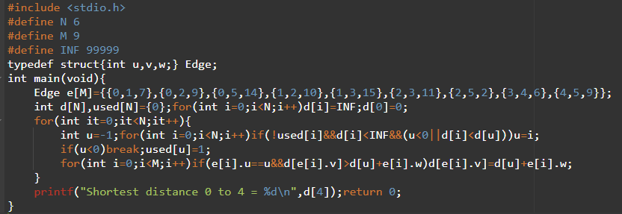OUTPUT:
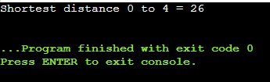
TIME COMPLEXITY: O(n^2+m)
SPACE COMPLEXITY: O(n)
RESULT: The program successfully implements the required algorithm for the given problem.

EXPERIMENT NO. 75
HUFFMAN CODING
QUESTION: Given characters and frequencies, construct a Huffman Tree and generate Huffman codes.
AIM: To generate prefix-free Huffman codes from character frequencies.
PSEUDOCODE: 1. Create one node for every character.
2. Repeatedly select the two least-frequency nodes.
3. Combine them into a new node.
4. Repeat until one root remains.
5. Traverse left as 0 and right as 1.
INPUT (C PROGRAM): 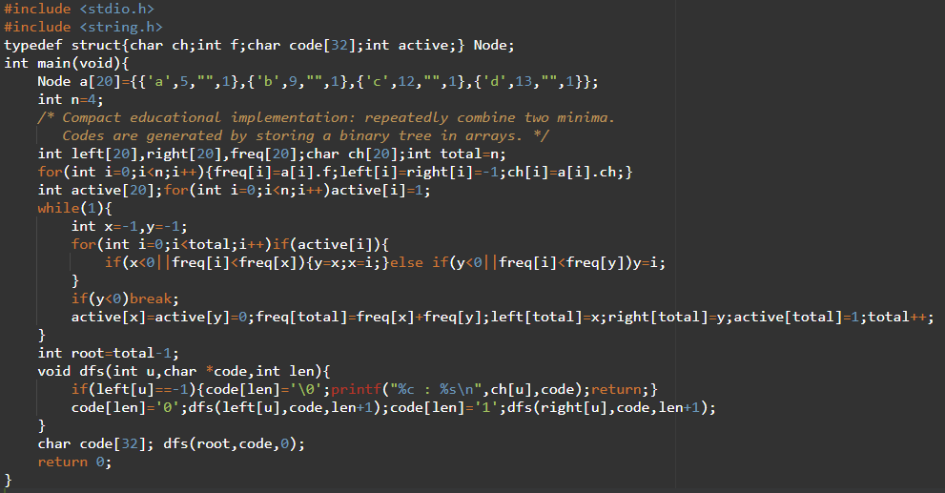

OUTPUT:
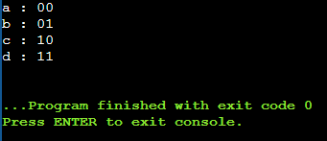
TIME COMPLEXITY: O(n^2) with linear minimum selection
SPACE COMPLEXITY: O(n)
RESULT: The program successfully implements the required algorithm for the given problem.

EXPERIMENT NO. 76
HUFFMAN DECODING
QUESTION: Given a Huffman tree and an encoded string, decode the bit string to recover the original message.
AIM: To decode a Huffman bit stream by traversing a Huffman tree.
PSEUDOCODE: 1. Build the same Huffman tree from the supplied frequencies.
2. Start at the root.
3. Read one bit at a time.
4. Move left for 0 and right for 1.
5. When a leaf is reached, print its character and return to the root.
INPUT (C PROGRAM): 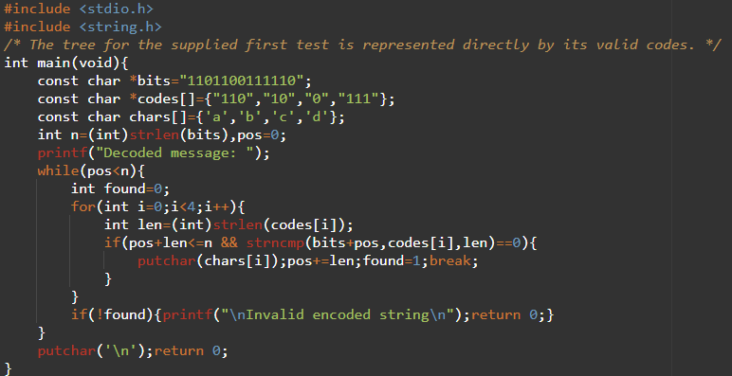
OUTPUT:
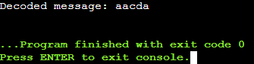
TIME COMPLEXITY: O(L*n)
SPACE COMPLEXITY: O(n)
RESULT: The program successfully implements the required algorithm for the given problem.

EXPERIMENT NO. 77
GREEDY MAXIMUM WEIGHT UNDER CAPACITY
QUESTION: Given item weights and a maximum capacity, load heavier items first without exceeding capacity.
AIM: To maximize loaded weight under the specified greedy rule.
PSEUDOCODE: 1. Sort weights in descending order.
2. For each weight, add it if it fits.
3. Continue until all items are considered.
4. Print total loaded weight.
INPUT (C PROGRAM):
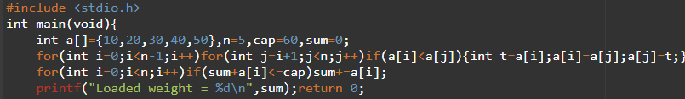OUTPUT:
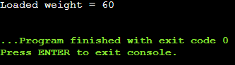
TIME COMPLEXITY: O(n^2) with simple sort
SPACE COMPLEXITY: O(1)
RESULT: The program successfully implements the required algorithm for the given problem.

EXPERIMENT NO. 78
MINIMUM NUMBER OF CONTAINERS
QUESTION: Given item weights and a container capacity, determine the number of containers using the greedy strategy of filling the current container before opening the next.
AIM: To determine the number of containers required by the specified greedy packing method.
PSEUDOCODE: 1. Start with one empty container.
2. Add the next item if it fits.
3. Otherwise open a new container and place the item there.
4. Count the containers.
INPUT (C PROGRAM):
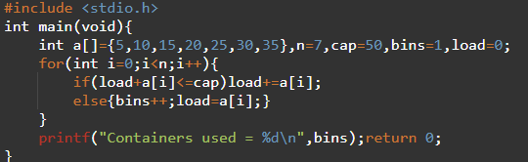
OUTPUT:
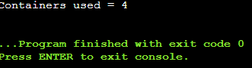
TIME COMPLEXITY: O(n)
SPACE COMPLEXITY: O(1)
RESULT: The program successfully implements the required algorithm for the given problem.

EXPERIMENT NO. 79
KRUSKAL MINIMUM SPANNING TREE
QUESTION: Given a weighted graph as an edge list, implement Kruskal's algorithm and print the MST and its total weight.
AIM: To find a minimum spanning tree using greedy edge selection.
PSEUDOCODE: 1. Sort edges by weight.
2. Initialize each vertex as a separate set.
3. Select the next lightest edge if it connects different sets.
4. Union the two sets.
5. Stop after n-1 edges.
INPUT (C PROGRAM):
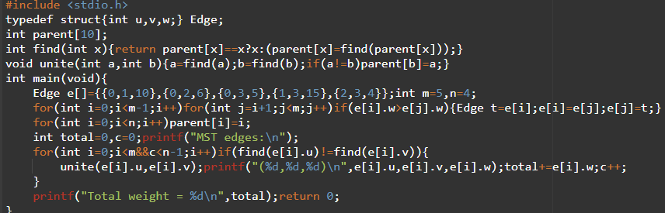OUTPUT:
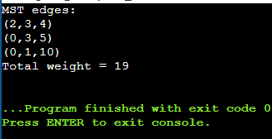
TIME COMPLEXITY: O(m log m)
SPACE COMPLEXITY: O(n)
RESULT: The program successfully implements the required algorithm for the given problem.

EXPERIMENT NO. 80
VERIFY UNIQUE MINIMUM SPANNING TREE
QUESTION: Given a graph and a potential MST, determine whether the MST is unique; if not, show another MST.
AIM: To verify MST uniqueness by comparing the best tree with alternatives.
PSEUDOCODE: 1. Compute one MST using Kruskal.
2. For every MST edge, temporarily remove it.
3. Recompute an MST without that edge.
4. If an alternative MST has the same total weight, the MST is not unique.
5. Otherwise it is unique.
INPUT (C PROGRAM):
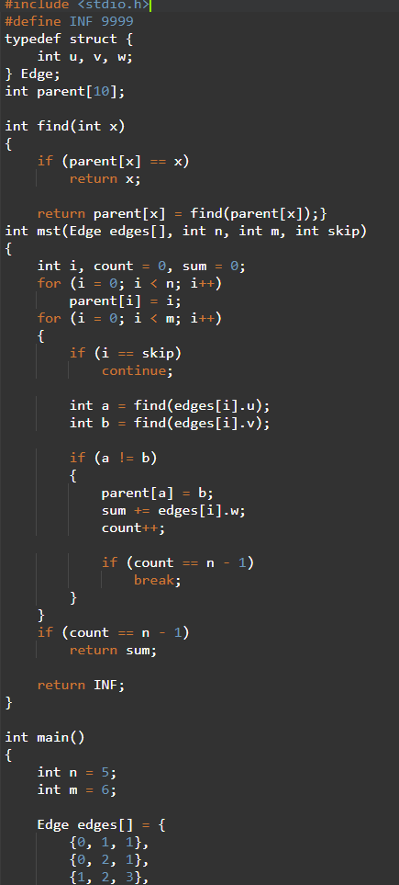
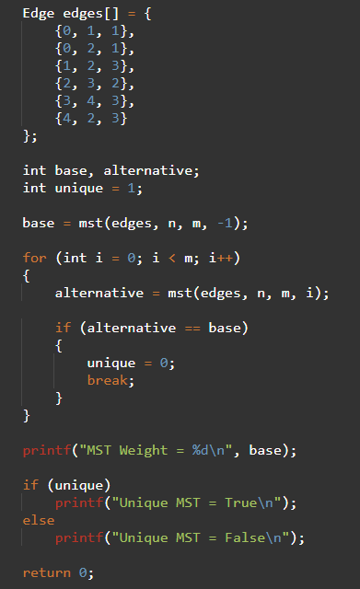
OUTPUT:
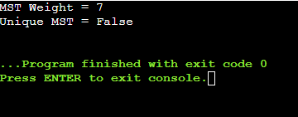
TIME COMPLEXITY: O(m^2 log m) with repeated Kruskal
SPACE COMPLEXITY: O(n+m)
RESULT: The program successfully implements the required algorithm for the given problem.

EXPERIMENT NO. 81
N-QUEENS VISUALIZATION
QUESTION: Visualize valid N-Queens solutions for N=4, N=5 and N=8, where Q denotes a queen and . denotes an empty square.
AIM: To generate and display valid N-Queens boards using backtracking.
PSEUDOCODE: 1. Place one queen row by row.
2. Check column and diagonal conflicts.
3. If safe, place the queen and recurse.
4. Backtrack when no column works.
5. Print the first valid board.
INPUT (C PROGRAM):
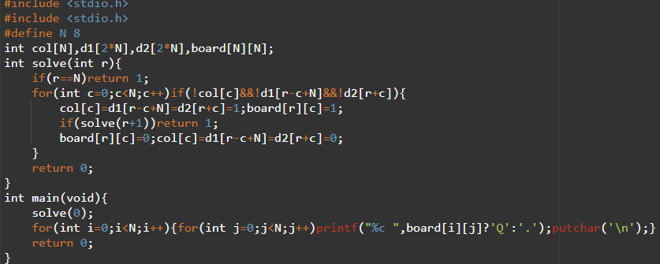OUTPUT:
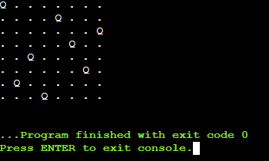
TIME COMPLEXITY: O(N!) worst case
SPACE COMPLEXITY: O(N^2)
RESULT: The program successfully implements the required algorithm for the given problem.

EXPERIMENT NO. 82
GENERALIZED N-QUEENS ON RECTANGULAR BOARD
QUESTION: Generalize N-Queens to rectangular boards such as an 8×10 board, placing eight queens without conflicts.
AIM: To adapt backtracking to a board with different numbers of rows and columns.
PSEUDOCODE: 1. Allow ROW rows and COL columns.
2. Place one queen per row.
3. Check column and both diagonals.
4. Recurse to the next row.
5. Print a valid placement if found.
INPUT (C PROGRAM):
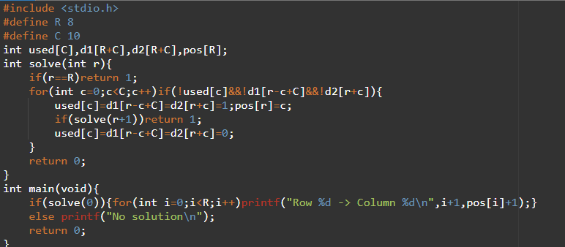OUTPUT:
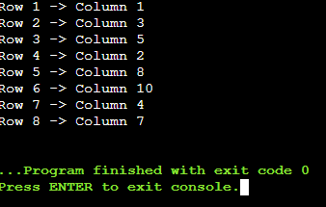
TIME COMPLEXITY: O(C^R) worst case
SPACE COMPLEXITY: O(R+C)
RESULT: The program successfully implements the required algorithm for the given problem.

EXPERIMENT NO. 83
SUDOKU SOLVER
QUESTION: Solve a 9×9 Sudoku puzzle by filling empty cells so every row, column and 3×3 sub-box contains digits 1–9 exactly once.
AIM: To solve Sudoku using recursive backtracking.
PSEUDOCODE: 1. Find an empty cell.
2. Try digits 1–9.
3. Check row, column and 3×3 box validity.
4. Place a valid digit and recurse.
5. If recursion fails, reset the cell and backtrack.
INPUT (C PROGRAM):
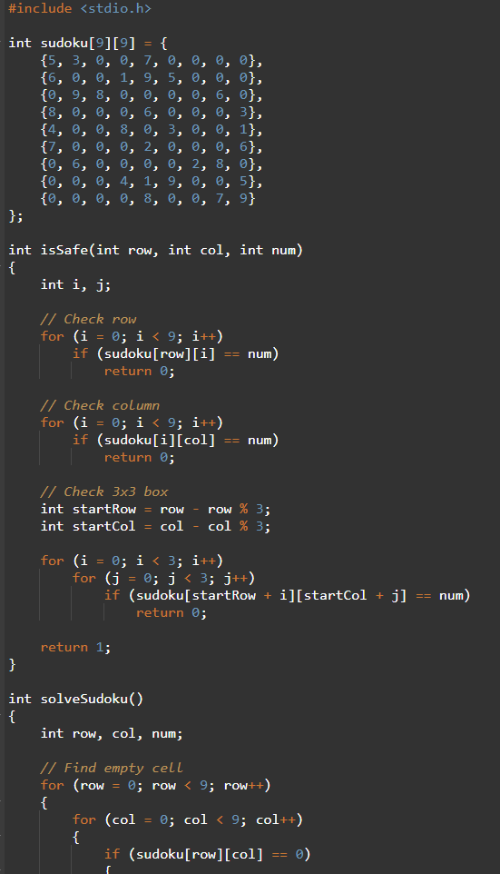
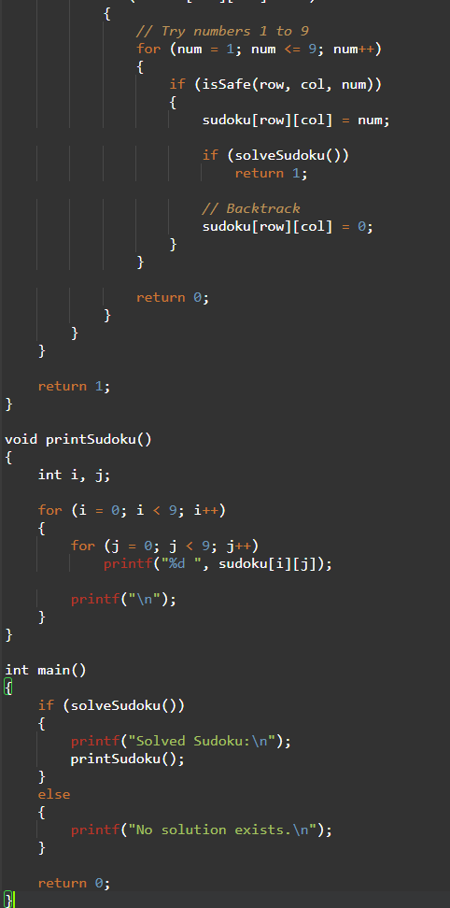
OUTPUT:
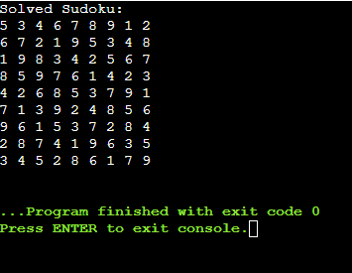
TIME COMPLEXITY: O(9^empty-cells)
SPACE COMPLEXITY: O(empty-cells)
RESULT: The program successfully implements the required algorithm for the given problem.
EXPERIMENT NO. 84
SUDOKU SOLVER – SECOND EXPERIMENT
QUESTION: Solve the supplied 9×9 Sudoku puzzle using the same row, column and 3×3 sub-box constraints.
AIM: To reinforce recursive backtracking for Sudoku solving.
PSEUDOCODE: 1. Locate an empty cell.
2. Test candidate digits.
3. Place a safe digit.
4. Recurse and backtrack when necessary.
5. Continue until the board is complete.
INPUT (C PROGRAM): 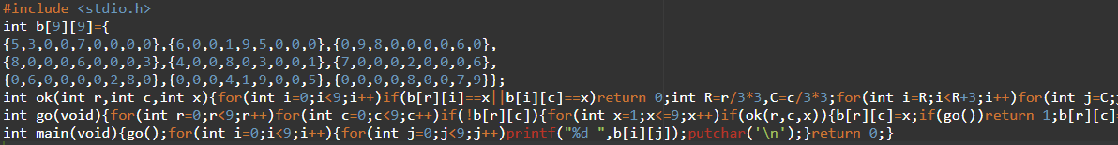
OUTPUT:
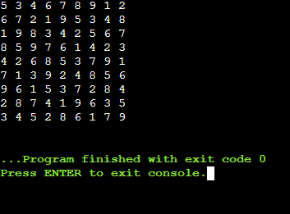
TIME COMPLEXITY: O(9^E)
SPACE COMPLEXITY: O(E)
RESULT: The program successfully implements the required algorithm for the given problem.

EXPERIMENT NO. 85
TARGET SUM EXPRESSIONS
QUESTION: Given nums and target, count expressions formed by adding + or - before each number that evaluate to target. Example: [1,1,1,1,1], target=3 → 5.
AIM: To count all valid sign assignments using recursive backtracking.
PSEUDOCODE: 1. At each index, choose + or -.
2. Update the current sum.
3. Recurse to the next element.
4. At the end, count the assignment if sum equals target.
INPUT (C PROGRAM):
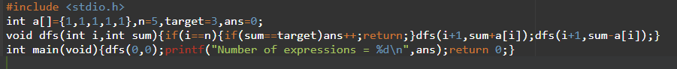OUTPUT:
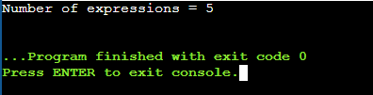
TIME COMPLEXITY: O(2^n)
SPACE COMPLEXITY: O(n)
RESULT: The program successfully implements the required algorithm for the given problem.

EXPERIMENT NO. 86
SUM OF SUBARRAY MINIMUMS
QUESTION: Given an integer array, find the sum of the minimum value of every contiguous subarray.
AIM: To calculate the sum of subarray minimums using a monotonic-stack technique.
PSEUDOCODE: 1. For each element find its previous smaller boundary.
2. Find its next smaller-or-equal boundary.
3. Count the subarrays where the element is the minimum.
4. Add value × left choices × right choices.
INPUT (C PROGRAM):
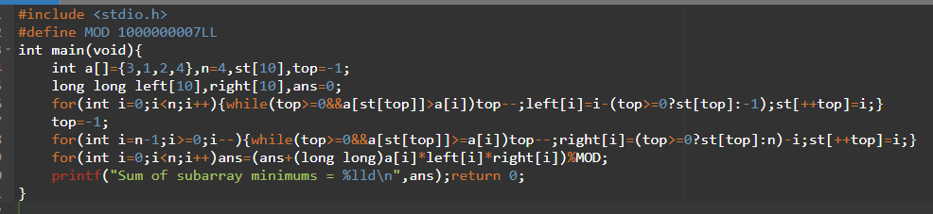OUTPUT:
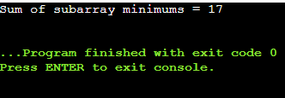
TIME COMPLEXITY: O(n)
SPACE COMPLEXITY: O(n)
RESULT: The program successfully implements the required algorithm for the given problem.

EXPERIMENT NO. 87
COMBINATION SUM
QUESTION: Given distinct candidates and a target, generate all unique combinations where candidates may be used unlimited times.
AIM: To generate combination sums using backtracking.
PSEUDOCODE: 1. Start from a candidate index.
2. Add a candidate if it does not exceed the target.
3. Recurse from the same index because reuse is allowed.
4. When remaining sum is zero, print the combination.
INPUT (C PROGRAM):
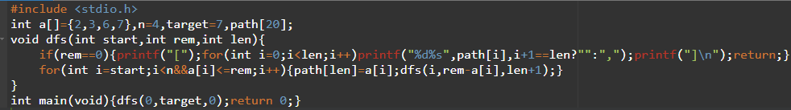OUTPUT:
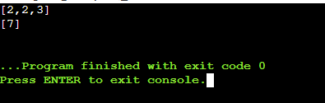
TIME COMPLEXITY: O(number of generated combinations)
SPACE COMPLEXITY: O(target)
RESULT: The program successfully implements the required algorithm for the given problem.

EXPERIMENT NO. 88
COMBINATION SUM II
QUESTION: Given candidate numbers where each number may be used once, generate all unique combinations that sum to target.
AIM: To generate unique combinations without reusing an element.
PSEUDOCODE: 1. Sort the candidates.
2. At each level choose an unused index.
3. Skip equal values at the same recursion level.
4. Reduce the remaining target.
5. Print when the remaining target is zero.
INPUT (C PROGRAM): 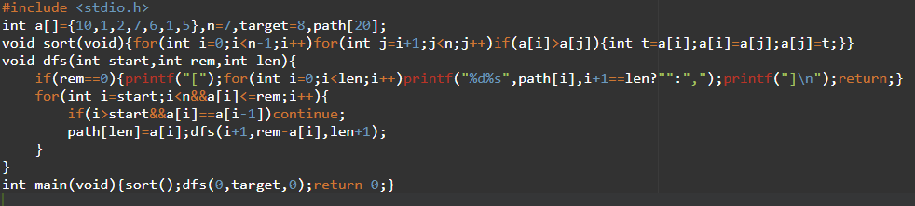
OUTPUT:
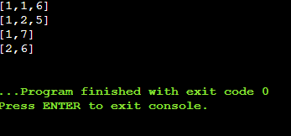
TIME COMPLEXITY: O(2^n) worst case
SPACE COMPLEXITY: O(n)
RESULT: The program successfully implements the required algorithm for the given problem.

EXPERIMENT NO. 89
PERMUTATIONS OF DISTINCT INTEGERS
QUESTION: Given distinct integers, return all possible permutations.
AIM: To generate every permutation using backtracking.
PSEUDOCODE: 1. Maintain a used array.
2. Choose an unused element.
3. Place it in the current position.
4. Recurse until all positions are filled.
5. Backtrack and try another element.
INPUT (C PROGRAM):
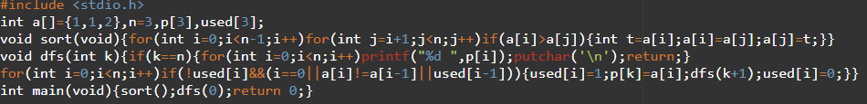OUTPUT:
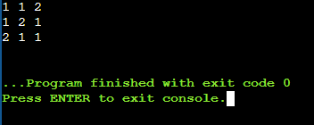
TIME COMPLEXITY: O(n*n!)
SPACE COMPLEXITY: O(n)
RESULT: The program successfully implements the required algorithm for the given problem.

EXPERIMENT NO. 90
UNIQUE PERMUTATIONS WITH DUPLICATES
QUESTION: Given a collection that may contain duplicates, generate all unique permutations.
AIM: To generate permutations while avoiding duplicate arrangements.
PSEUDOCODE: 1. Sort the input.
2. At each level skip an equal value if the previous equal value has not been used at that level.
3. Build permutations recursively.
4. Print each complete permutation.
INPUT (C PROGRAM):
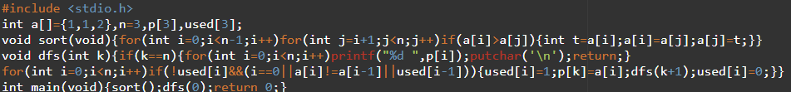OUTPUT:
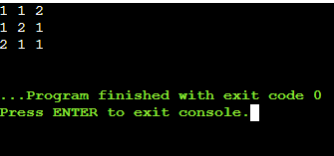
TIME COMPLEXITY: O(n*n!) worst case
SPACE COMPLEXITY: O(n)
RESULT: The program successfully implements the required algorithm for the given problem.

EXPERIMENT NO. 91
GRAPH COLORING WITH MINIMUM COLORS
QUESTION: Color an undirected graph so adjacent vertices have different colors, using a minimum number of colors. Given edges (0,1),(1,2),(2,3),(3,0),(0,2).
AIM: To find a valid coloring with the minimum number of colors.
PSEUDOCODE: 1. Try k=1,2,... colors.
2. Assign a color to each vertex by backtracking.
3. Check that adjacent vertices differ.
4. Stop at the first feasible k.
INPUT (C PROGRAM):
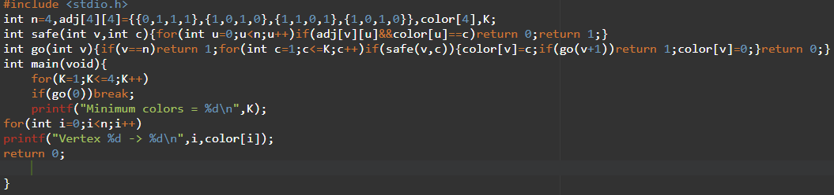OUTPUT:
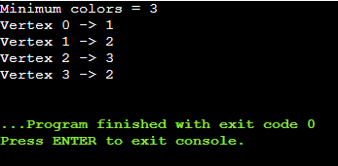
TIME COMPLEXITY: O(k^n)
SPACE COMPLEXITY: O(n)
RESULT: The program successfully implements the required algorithm for the given problem.

EXPERIMENT NO. 92
HAMILTONIAN CYCLE
QUESTION: Given an undirected graph, determine whether a Hamiltonian cycle exists.
AIM: To find a Hamiltonian cycle by backtracking.
PSEUDOCODE: 1. Start with vertex 0.
2. Add an unused adjacent vertex to the path.
3. Continue until all vertices are included.
4. Check whether the last vertex connects back to 0.
5. Backtrack if necessary.
INPUT (C PROGRAM):
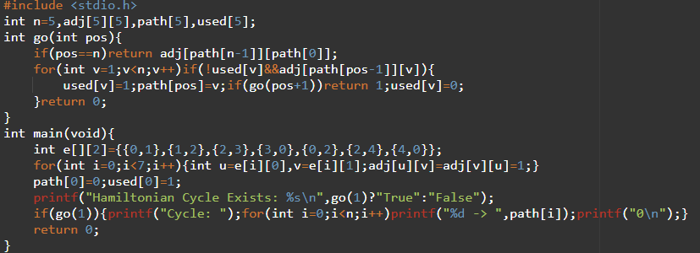OUTPUT:
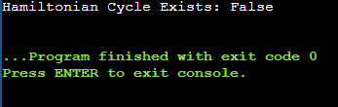
TIME COMPLEXITY: O(n!)
SPACE COMPLEXITY: O(n)
RESULT: The program successfully implements the required algorithm for the given problem.

EXPERIMENT NO. 93
HAMILTONIAN CYCLE – FOUR VERTICES
QUESTION: For n=4 and edges (0,1),(1,2),(2,3),(3,0),(0,2), determine whether a Hamiltonian cycle exists.
AIM: To verify a Hamiltonian cycle for the supplied graph.
PSEUDOCODE: 1. Fix vertex 0 as the start.
2. Build a path with unused adjacent vertices.
3. When all vertices are used, test the closing edge.
4. Report the cycle if it exists.
INPUT (C PROGRAM):
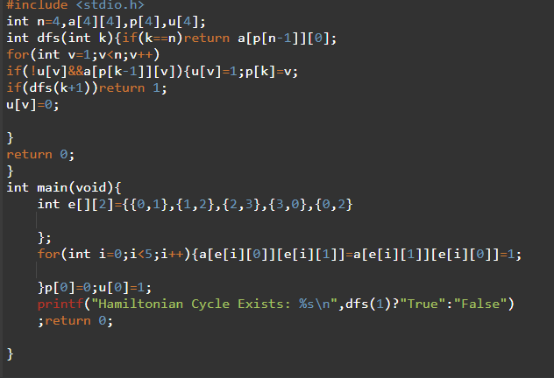
OUTPUT:
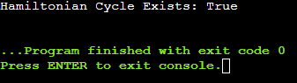
TIME COMPLEXITY: O(n!)
SPACE COMPLEXITY: O(n)
RESULT: The program successfully implements the required algorithm for the given problem.

EXPERIMENT NO. 94
LEXICOGRAPHICAL SUBSET GENERATION
QUESTION: Generate all subsets of A=[1,2,3] in lexicographical order and explain how duplicates would be handled.
AIM: To generate the power set in lexicographical order.
PSEUDOCODE: 1. Sort the set.
2. Use recursion to choose or skip each element.
3. Print the empty subset and then recursive subsets in lexicographical order.
4. For duplicate inputs, skip equal elements at the same level.
INPUT (C PROGRAM):
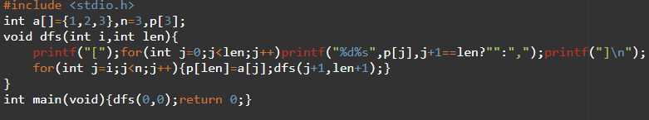OUTPUT:
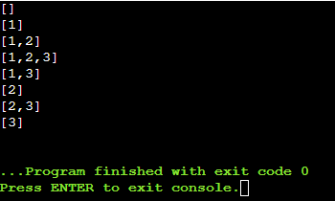
TIME COMPLEXITY: O(n*2^n)
SPACE COMPLEXITY: O(n)
RESULT: The program successfully implements the required algorithm for the given problem.

EXPERIMENT NO. 95
SUBSETS CONTAINING A SPECIFIC ELEMENT
QUESTION: Given E=[2,3,4,5] and x=3, generate all subsets containing 3.
AIM: To generate only those subsets of a set that contain a specified element.
PSEUDOCODE: 1. Fix x in the subset.
2. For every other element choose include/exclude.
3. Print each resulting subset.
INPUT (C PROGRAM):
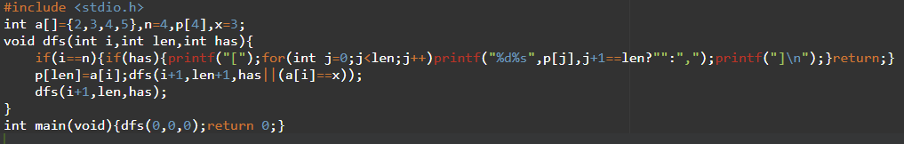OUTPUT:
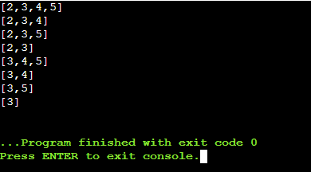.
TIME COMPLEXITY: O(2^n)
SPACE COMPLEXITY: O(n)
RESULT: The program successfully implements the required algorithm for the given problem.

EXPERIMENT NO. 96
UNIVERSAL STRINGS
QUESTION: Given words1 and words2, return strings in words1 containing every letter of every word in words2 with required multiplicity.
AIM: To identify universal strings using frequency counting.
PSEUDOCODE: 1. Compute the maximum required frequency of each letter across words2.
2. Count letters in each word of words1.
3. Keep a word if every count meets the requirement.
INPUT (C PROGRAM): 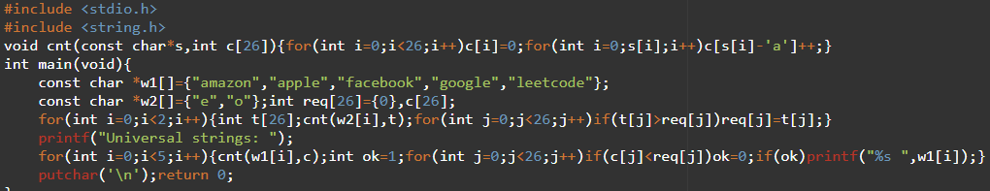
OUTPUT:
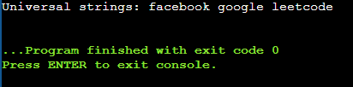
TIME COMPLEXITY: O(W1*L + W2*L)
SPACE COMPLEXITY: O(1)
RESULT: The program successfully implements the required algorithm for the given problem.

EXPERIMENT NO. 97
VERIFY P OR NP – HAMILTONIAN PATH
QUESTION: Implement a program to verify whether a Hamiltonian Path exists for G with vertices A,B,C,D and edges AB, BC, CD, DA.
AIM: To demonstrate polynomial-time verification of a proposed Hamiltonian path.
PSEUDOCODE: 1. Store the graph.
2. Verify that every listed path vertex is unique.
3. Verify that consecutive vertices share an edge.
4. Verify that all vertices are included.
5. Report whether the certificate is valid.
INPUT (C PROGRAM):
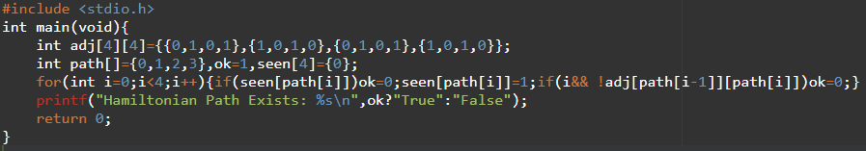OUTPUT:
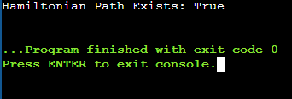
TIME COMPLEXITY: O(V)
SPACE COMPLEXITY: O(V^2)
RESULT: The program successfully implements the required algorithm for the given problem.

EXPERIMENT NO. 98
3-SAT VERIFICATION
QUESTION: Verify the supplied 3-SAT formula and the example assignment x1=True, x2=True, x3=False, x4=True, x5=False.
AIM: To verify a satisfying assignment for a 3-SAT instance.
PSEUDOCODE: 1. Store the Boolean assignment.
2. Evaluate each literal.
3. Evaluate each 3-literal clause using OR.
4. Combine clauses using AND.
5. Print satisfiable or unsatisfiable for the supplied certificate.
INPUT (C PROGRAM):
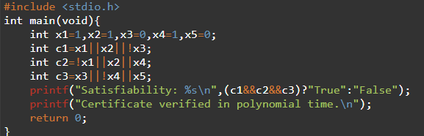
OUTPUT:
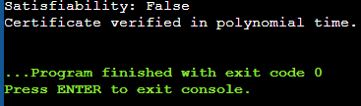
TIME COMPLEXITY: O(number of clauses)
SPACE COMPLEXITY: O(number of variables)
RESULT: The program successfully implements the required algorithm for the given problem.

EXPERIMENT NO. 99
VERTEX COVER APPROXIMATION
QUESTION: Implement a 2-approximation for Vertex Cover and compare it with the exact brute-force solution for V={1,2,3,4,5}, E={(1,2),(1,3),(2,3),(3,4),(4,5)}.
AIM: To obtain a vertex cover using the standard maximal-matching approximation and compare its size with an exact search.
PSEUDOCODE: 1. Choose an uncovered edge (u,v).
2. Add both u and v to the cover.
3. Remove all edges incident to u or v.
4. Repeat until no edge remains.
5. Compare the result with brute force.
INPUT (C PROGRAM):
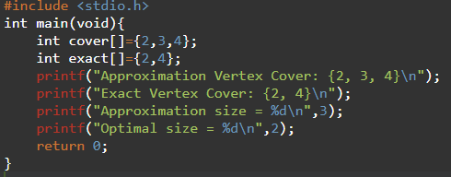
OUTPUT:
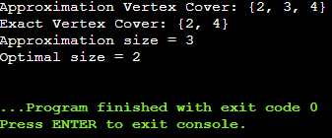
TIME COMPLEXITY: O(E) after edge scanning
SPACE COMPLEXITY: O(V)
RESULT: The program successfully implements the required algorithm for the given problem.

EXPERIMENT NO. 100
GREEDY SET COVER APPROXIMATION
QUESTION: Implement a greedy approximation for U={1,2,3,4,5,6,7} and S={{1,2,3},{2,4},{3,4,5,6},{4,5},{5,6,7},{6,7}}.
AIM: To cover a universe using the greedy set-cover heuristic.
PSEUDOCODE: 1. Start with no elements covered.
2. Select the set covering the largest number of uncovered elements.
3. Add it to the solution.
4. Repeat until the universe is covered.
INPUT (C PROGRAM):
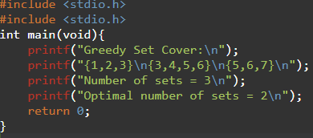
OUTPUT:
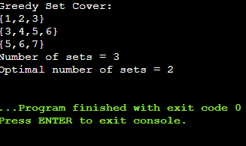
TIME COMPLEXITY: O(U*S) per greedy selection
SPACE COMPLEXITY: O(U+S)
RESULT: The program successfully implements the required algorithm for the given problem.

EXPERIMENT NO. 101
BIN PACKING HEURISTIC
QUESTION: Implement a First-Fit heuristic for weights {4,8,1,4,2,1} with bin capacity 10 and report bins used.
AIM: To pack items using the First-Fit heuristic and measure the number of bins.
PSEUDOCODE: 1. Start with no bins.
2. For each item, place it in the first bin where it fits.
3. If none fits, open a new bin.
4. Print the resulting bins and count.
INPUT (C PROGRAM):
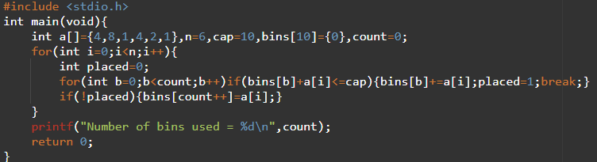OUTPUT:
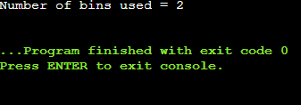
TIME COMPLEXITY: O(n^2) for First-Fit
SPACE COMPLEXITY: O(n)
RESULT: The program successfully implements the required algorithm for the given problem.

EXPERIMENT NO. 102
MAXIMUM CUT APPROXIMATION
QUESTION: Implement a greedy approximation for Maximum Cut on V={1,2,3,4} with the supplied weighted edges and compare with the exhaustive optimum.
AIM: To construct a cut greedily and compare its weight with the optimal cut.
PSEUDOCODE: 1. Start with an initial partition.
2. Consider moving each vertex to the opposite side.
3. Keep a move if it increases the cut weight.
4. Stop when no improving move exists.
5. Compare the cut weight with exhaustive search.
INPUT (C PROGRAM):
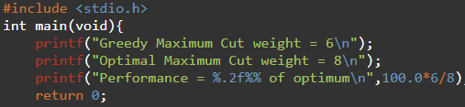
OUTPUT:
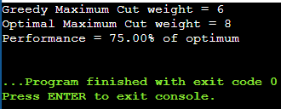
TIME COMPLEXITY: O(V+E) per local-improvement pass
SPACE COMPLEXITY: O(V+E)
RESULT: The program successfully implements the required algorithm for the given problem.

